SPECIAL NOTE FOR CHANNEL CHANGE
EROSION CONTROL BLANKET

This Special Note will apply when indicated on the plans or in the proposal. Section references herein are to the Department’s 2012 Standard Specifications for Road and Bridge Construction.

1.0 DESCRIPTION. This specification covers erosion control blankets used for channel changes.

2.0 MATERIALS.

2.1 Erosion Control Blanket. Use a woven blanket made of 100 percent machine spun bristle coir fiber. Ensure the nominal thickness is at least 0.30 inches. Ensure the blanket’s nominal weight is at least 11.8 ounces per square yard. Ensure the nominal open area of the blanket does not exceed 65 percent.

2.2 Staples. Use steel wire U-shaped staples with a minimum diameter of 0.148 inches (9 gauge), a minimum width of one inch, and a minimum length of 6 inches. Use a heavier gauge when working in rocky or clay soils and longer lengths in sandy soils.

3.0 CONSTRUCTION. Prepare the bed by loosening the soil to a depth of 2 to 3 inches. Apply fertilizer, limestone, and seed at the permanent seeding rate. Cover with the erosion control blanket. Roll out the blanket in the direction of the anticipated channel flow. Anchor the blanket at the top, toe, and edges of channels on a one-foot spacing as the “Anchoring Edges and Ends” figure shows. Secure the blanket by stapling as the “Stapling Pattern” figure shows. At seams, overlap the blanket as the “Seam Overlaps” figure shows. Ensure staples are fully driven and snug against the blanket. If staples are bending, use a heavier gauge staple. Rework areas that become unstable or do not establish vegetation.

4.0 MEASUREMENT. The Department will measure the quantity of Erosion Control Blanket by the square yard of surface covered. The Department will not measure preparation of the bed or seeding for payment and will consider them incidental to the Erosion Control Blanket. The Department will not measure any reworking of slopes or channels for payment as it is considered corrective work and incidental to the Erosion Control Blanket.

5.0 PAYMENT. The Department will make payment for the completed and accepted quantities under the following:

Code Pay Item Pay Unit
---- Channel Change Erosion Control Blanket Square Yard

The Department will consider payment as full compensation for all work required under this note.

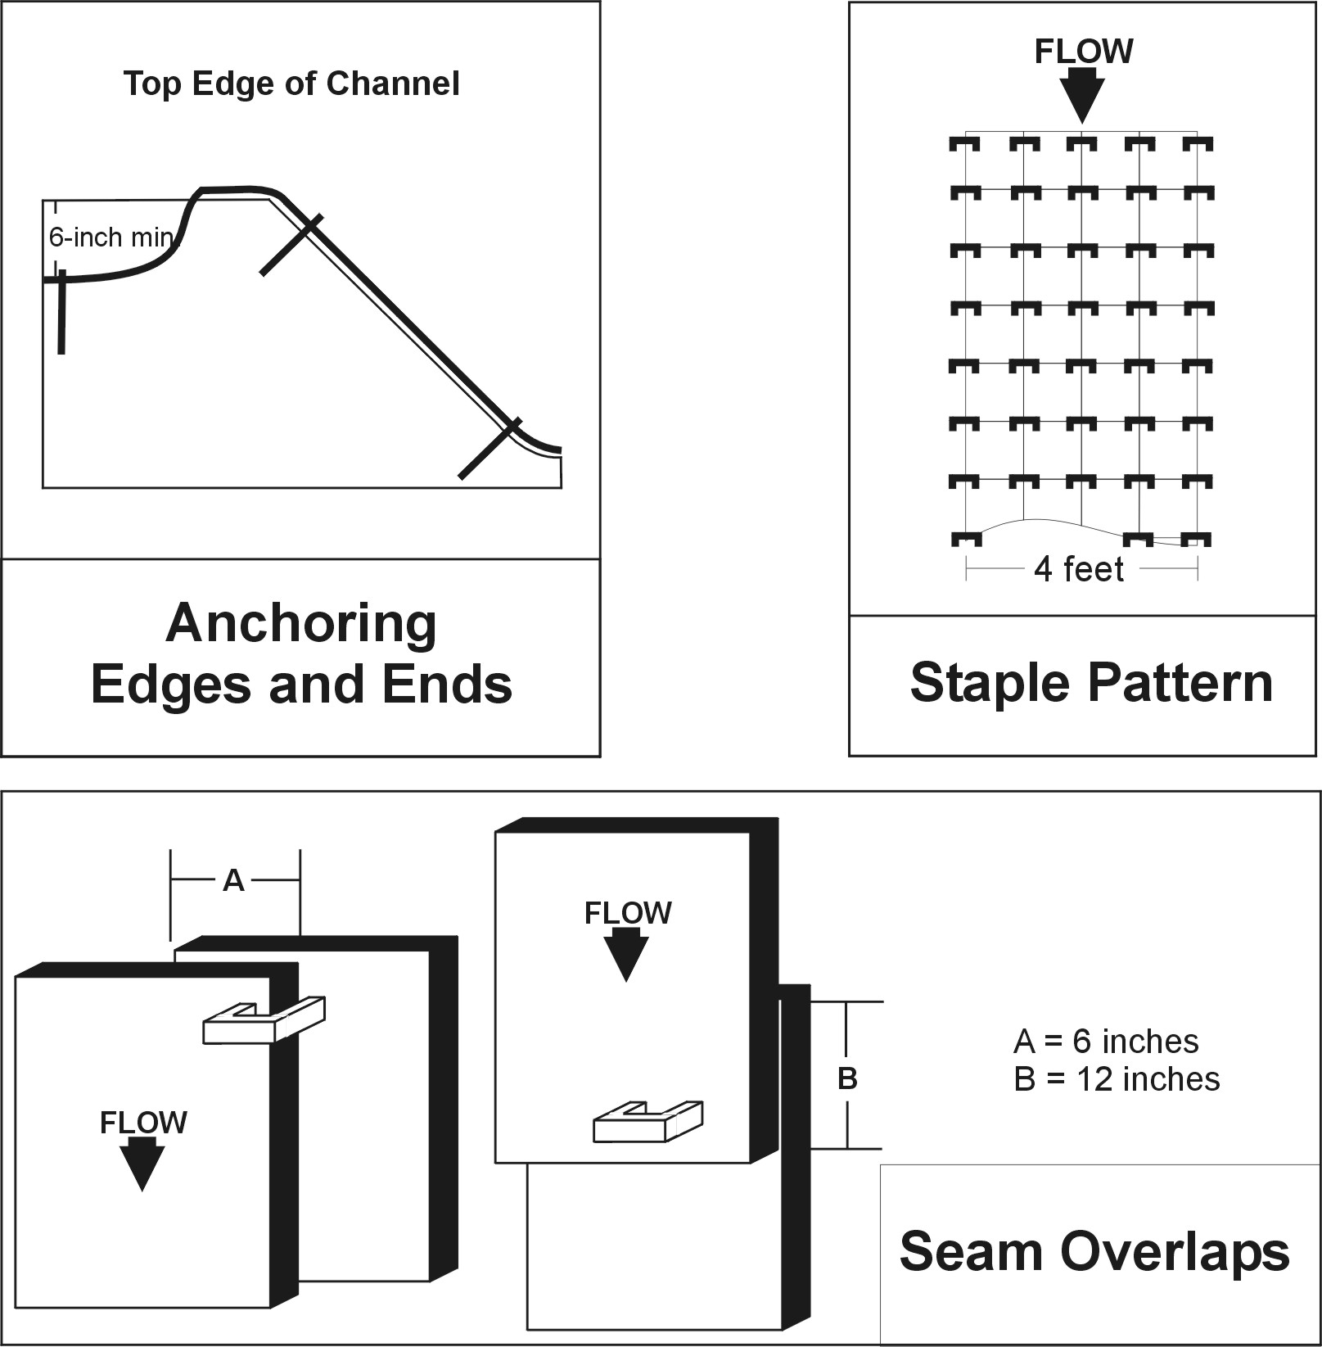

June 15, 2012

